Integrated Retail Analytics for Store Optimization and Demand Forecasting

Project Objective

- To utilize machine learning and data analysis techniques to optimize store performance, forecast demand, and enhance customer experience through segmentation and personalized marketing strategies.
- To foster long-term customer loyalty and satisfaction by delivering personalized experiences that exceed expectations. By continuously refining our strategies based on customer feedback and market insights, we can position ourselves as a trusted partner in meeting the evolving needs of our customers while driving sustainable business success in an increasingly competitive retail landscape.

Project Components

- About Dataset
- Data Preprocessing and Feature Engineering
- Exploratory Data Analysis
- Anomaly Detection in Sales Data
- Time-Based Anomaly Detection
- Customer Segmentation Analysis & Segmentation Quality Evaluation
- Personalization Strategies
- Market Basket Analysis
- Demand Forecasting
- Impact of External Factors
- Real-World Application and Strategy Formulation
- Conclusion

About Dataset
Content
You are provided with historical sales data for 45 stores located in different regions - each store contains a number of departments. The company also runs several promotional markdown events throughout the year. These markdowns precede prominent holidays, the four largest of which are the Super Bowl, Labor Day, Thanksgiving, and Christmas. The weeks including these holidays are weighted five times higher in the evaluation than non-holiday weeks.

Features data-set.csv:

Contains additional data related to the store, department, and regional activity for the given dates.

- Store - the store number
- Date - the week
- Temperature - average temperature in the region
- Fuel_Price - cost of fuel in the region
- MarkDown1-5-anonymized data related to promotional markdowns. MarkDown data is only available after Nov 2011, and is not available for all stores all the time. Any missing value is marked with an NA
- CPI - the consumer price index
- Unemployment - the unemployment rate
- IsHoliday - whether the week is a special holiday week

sales data-set.csv:

Anonymized information about the 45 stores, indicating the type and size of store

stores data-set.csv:

Historical sales data, which covers to 2010-02-05 to 2012-11-01. Within this tab you will find the following fields:

- Store - the store number
- Dept - the department number
- Date - the week
- Weekly_Sales - sales for the given department in the given store
- IsHoliday - whether the week is a special holiday week
Data Preprocessing and Feature Engineering
Changing datatype: Convert data type of dates column to datetime to extract days, months, weeks & year details.
Merging Datasets: Joined all the tables i.e. features, stores and sales table in a single table.
Handle Missing Values: Use techniques like median imputation due to anomalies to address missing values in your markdown columns.
This step ensures that you have a complete dataset for analysis.
Normalize Sales Data: Apply one of the normalization techniques discussed earlier to bring all sales data on a consistent scale. Applied Min-Max Scaling on the sales data.
Square root Transformation to handle skewness in numerical features.
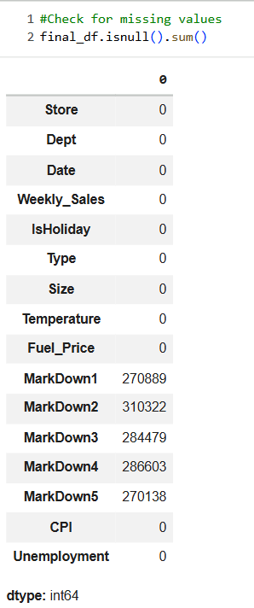
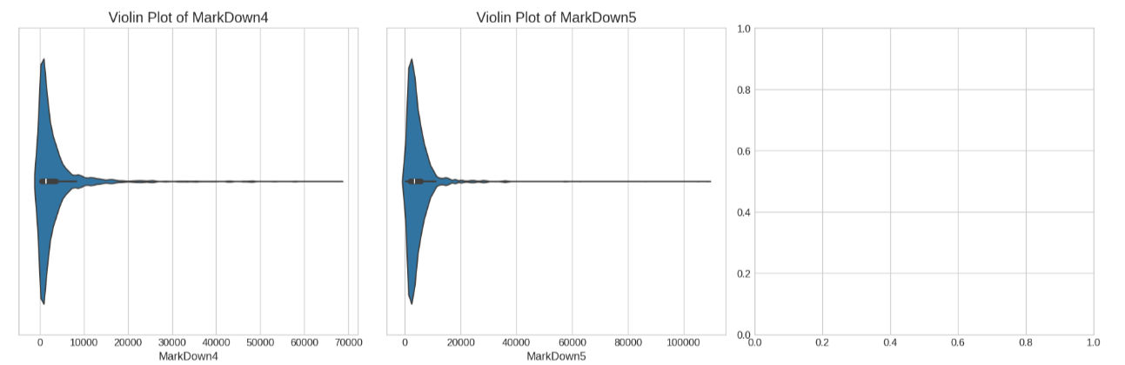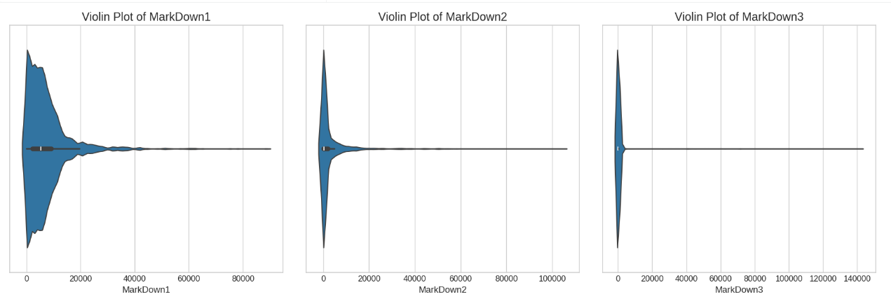

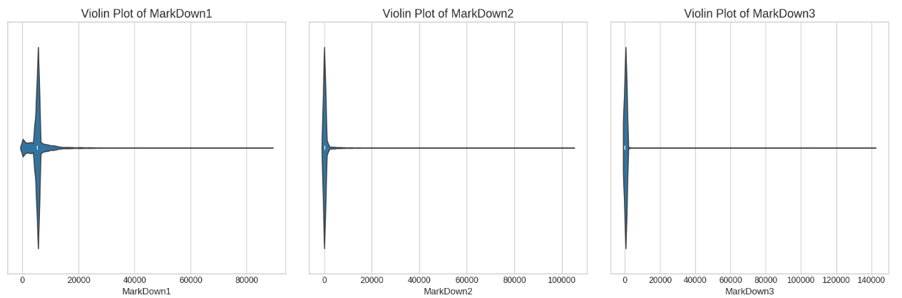
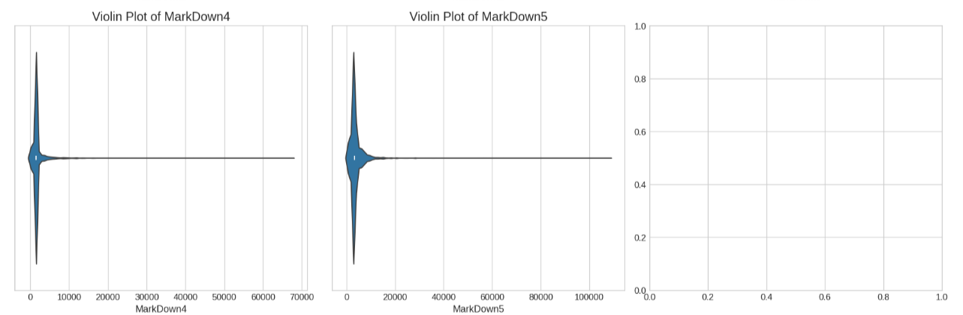
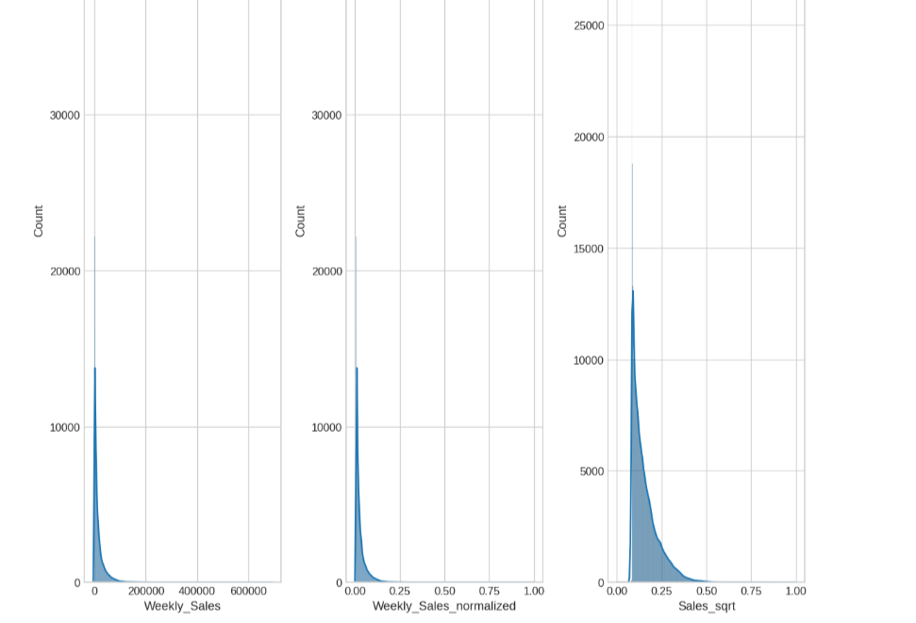

Exploratory Data Analysis
Chart 1 — Monthly Sales Trend + Rolling Avg
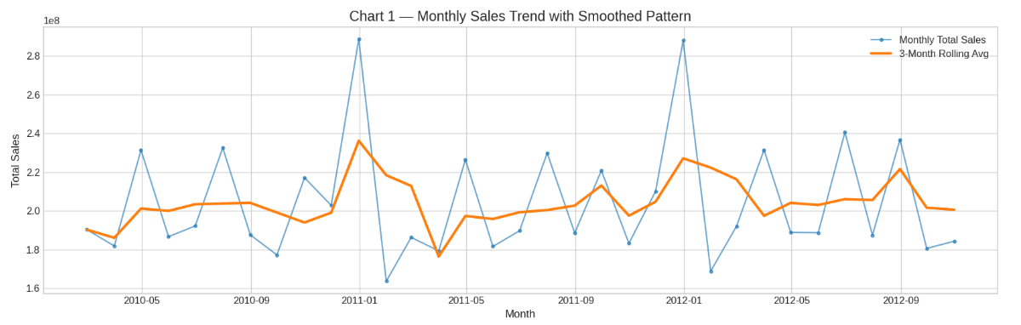
Insights found
- Sales show seasonal peaks, usually around holiday periods.
- Smoothed trend helps separate normal seasonal rise from random spikes.

Chart 2 — Sales Intensity Heatmap (Year × Month)
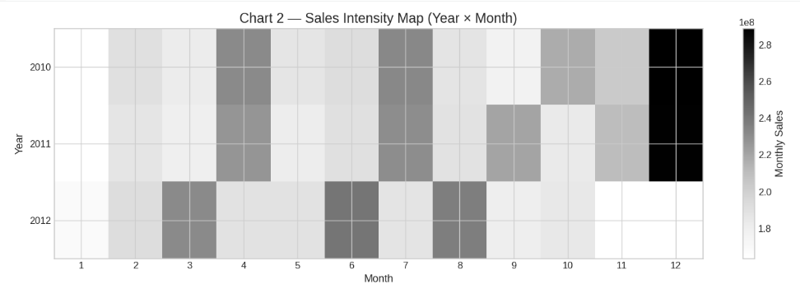
Insights found
- High-intensity blocks show strongest sales months.
- If a month’s intensity drops in a later year, it signals a performance change.

Chart 3 — Unemployment Trend (Smoothed)
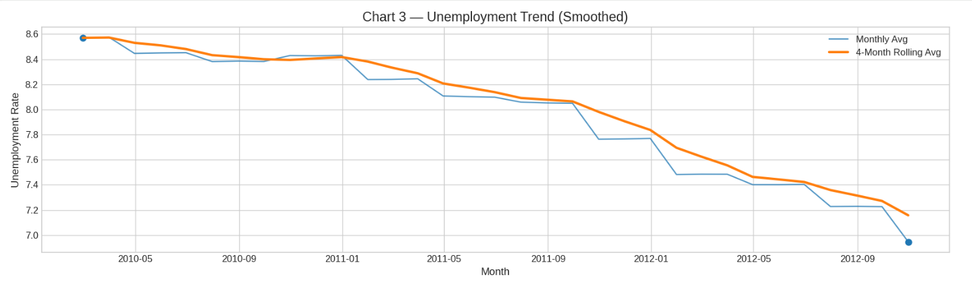
Insights found
- Gradual shifts indicate macroeconomic change that may affect spending power.
- Often impacts sales with a lag effect.

Chart 4 — CPI Growth Index
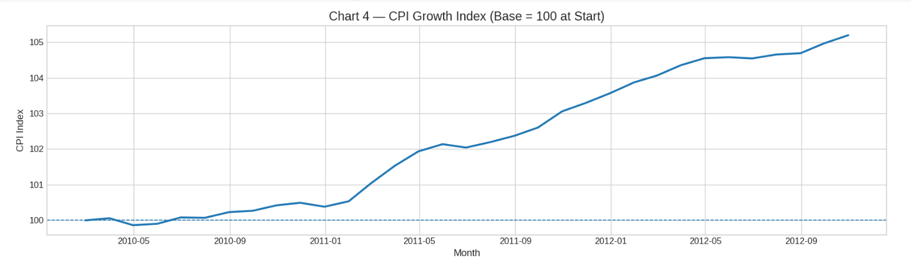
Insights found
- CPI rising indicates inflation.
- Inflation can shift buying behaviour toward discounted/value products.

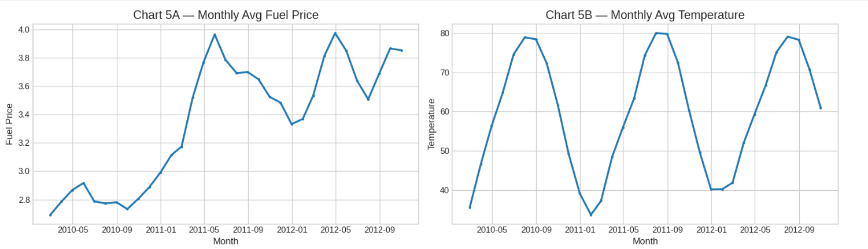
Chart 5 — Fuel Price & Temperature (Small Multiples)
Insights found
- Fuel price often shows a trend driven by economic conditions.
- Temperature follows seasonal cycles and affects seasonal demand patterns.

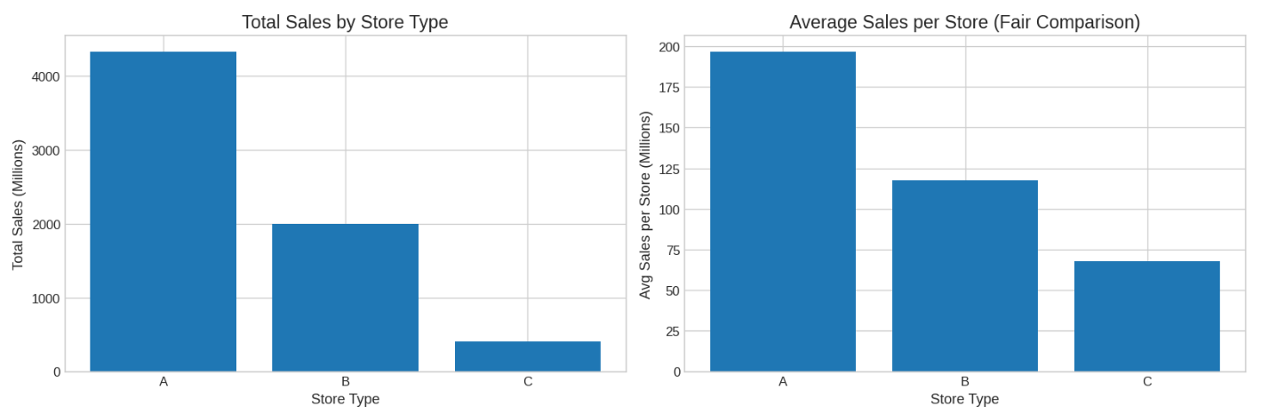
Chart 6 - Which type of store is the highest earner?
Insights found
- Total sales identifies which type contributes most revenue overall.
- Avg per store reveals whether the type is truly stronger or simply has more stores/size.

Chart 7 - Correlation of factors and weekly sales
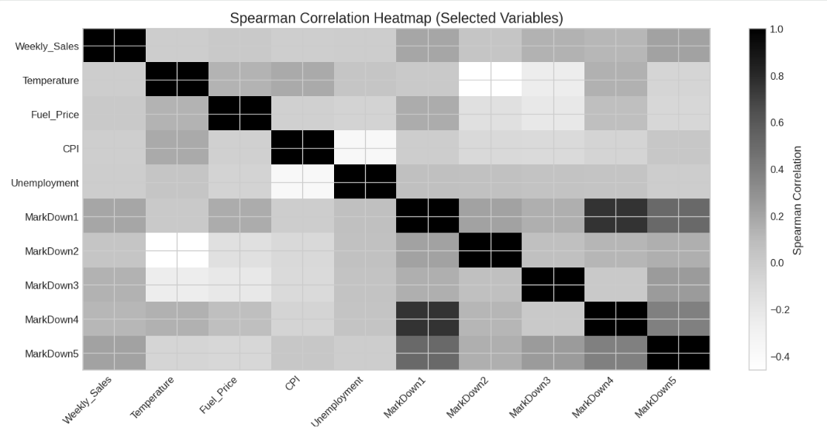
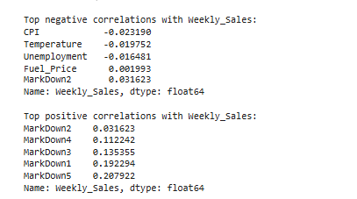

Insights found
- Weekly sales typically show weak direct correlation with macro features because:
- sales are driven strongly by seasonality/holidays/department effects.
- CPI & Unemployment often show negative relationship.

Anomaly Detection in Sales Data
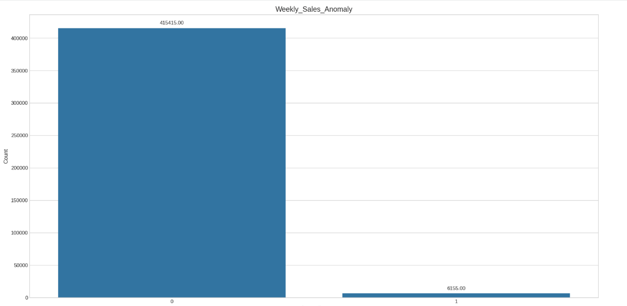
Handled Anomalous Data Points Using Interquartile Range (IQR) Technique

Objective-
Identify unusual sales patterns across stores and departments.
Investigate potential causes (e.g., holidays, markdowns, economic indicators).
Implement anomaly handling strategies to clean the data for further analysis.
What is Anomaly
Anomalies are deviations from expected behavior or patterns in data, and their presence can indicate issues or security threats.
Method used for Detecting Anomalies in Retail Data
Descriptive statistics are among the foundational methods for anomaly detection in retail. Techniques like mean, median, and standard deviation can be used to calculate summary statistics, which help identify point anomalies.
Mitigation Strategies
- Data Cleaning
- Data Normalization
- Data Imputation
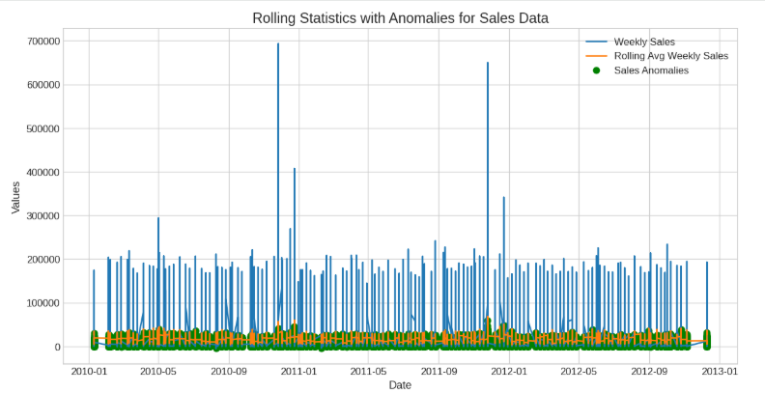
Time-Based Anomaly Detection
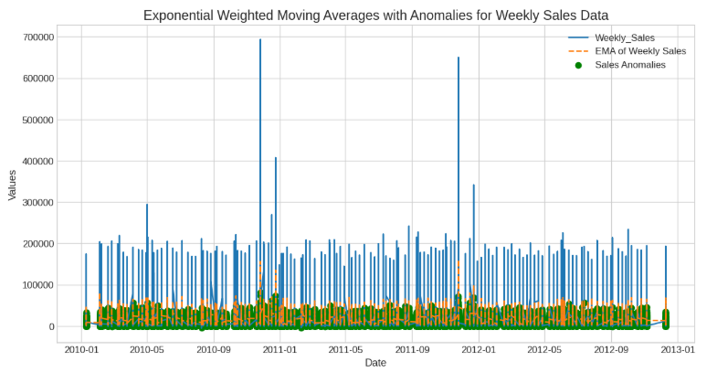

Objective-
Analyze sales trends over time.
Detect seasonal variations and holiday effects on sales.
Use time-series analysis for understanding store and department performance over time.
Detect anomalies in time series Sales data using specialized methods.

Approach:
Create Rolling Statistics: Calculate rolling averages, moving sums, and standard deviations to track data variations over time.
Apply Exponential Smoothing: Use exponential moving averages (EMA) and anomaly detection techniques to highlight unusual patterns in time series data.
Highlight Anomalies: Set thresholds and visual cues to identify significant deviations from smoothed values, aiding in anomaly detection and trend analysis.

Customer Segmentation Analysis
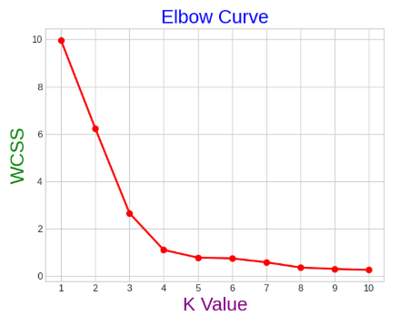
To identify the best number of clusters, I utilized the Elbow method.

Objective-
Segment stores or departments based on sales patterns, markdowns, and regional features.
Analyze segment-specific trends and characteristics
What is Segmentation
Customer segmentation is a critical marketing strategy that involves dividing a customer base into distinct groups based on specific criteria or characteristics.
Algorithm used for Segmentation in Retail Data
Applied the K-Means Clustering algorithm to segment stores and departments. K-Means Clustering is an unsupervised machine learning technique widely used for grouping data into clusters based on similarity.

Segmentation Quality Evaluation
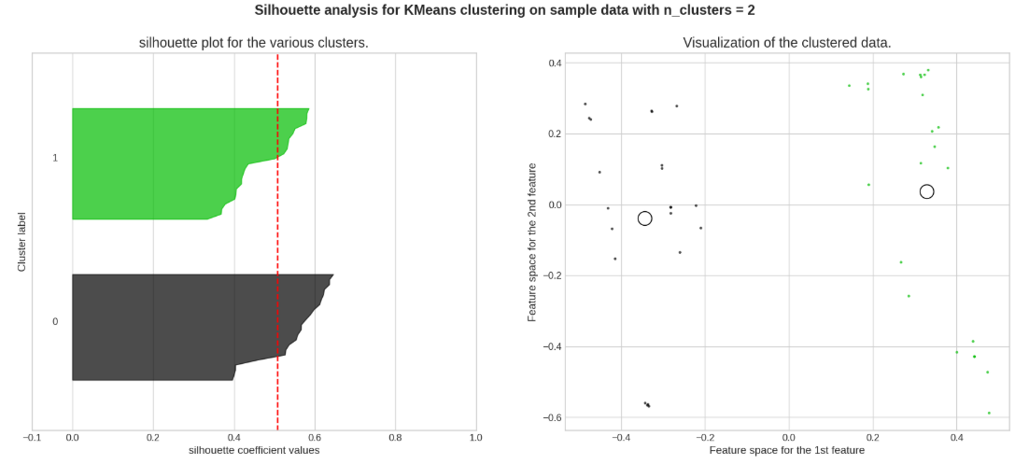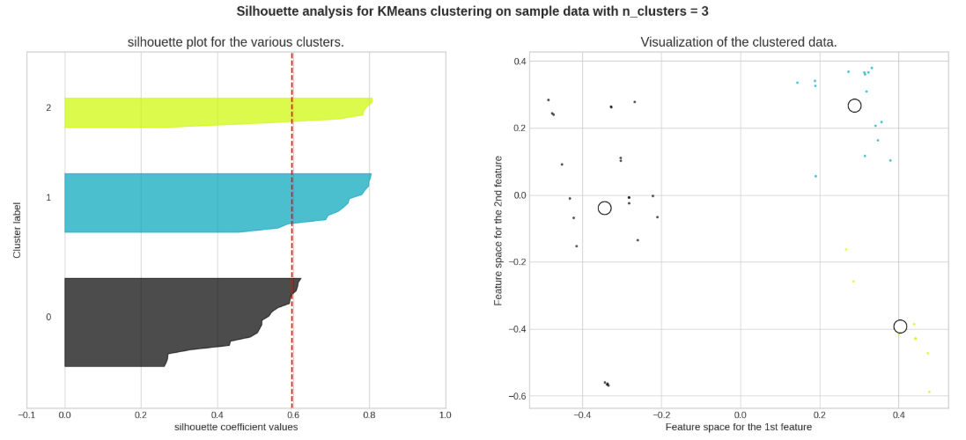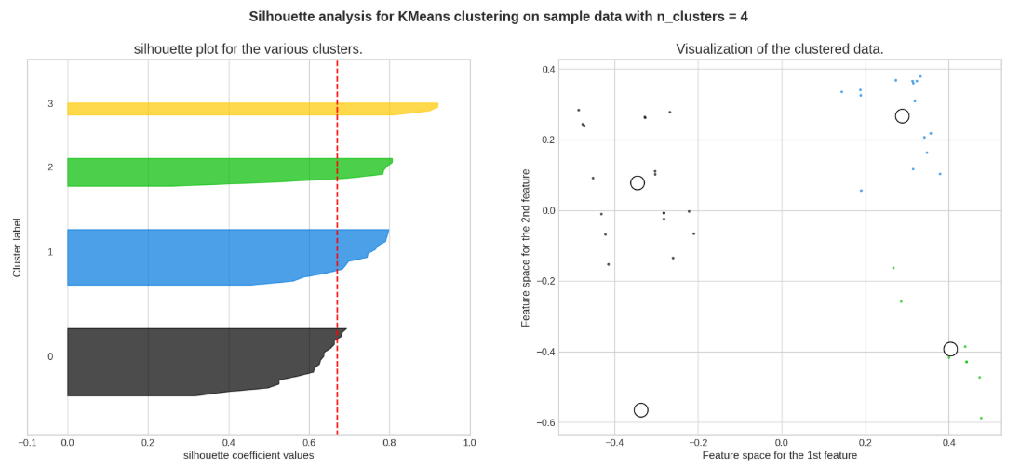
The optimal number of clusters is 4 according to silhouette score
Objective-
Evaluate the effectiveness of the customer segmentation.
Use metrics to assess the quality of segments in terms of homogeneity and separation.
Significance of Segmentation Quality Evaluation
The significance of segment quality evaluation lies in its ability to assess the effectiveness of clustering techniques in partitioning data into meaningful groups. It allows us to measure how well the clusters represent the underlying structure of the data and how distinct they are from each other.
This information is crucial for making informed decisions and drawing actionable insights from the clustered data, such as personalized marketing strategies
Metric used for Segmentation Quality Evaluation in Retail Data
Utilized the silhouette score metric to evaluate the quality of segments and select the most suitable cluster configuration.
A silhouette score closer to 1 indicates better segmentation quality, and after analysis, we determined the optimal number of clusters to be 4 for both store and department segments.

Personalization Strategies
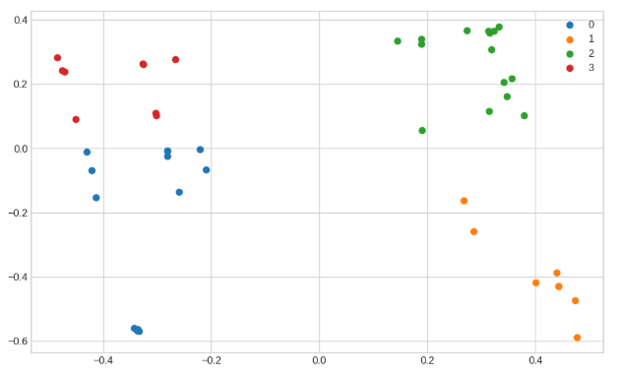

Store Segments Plot

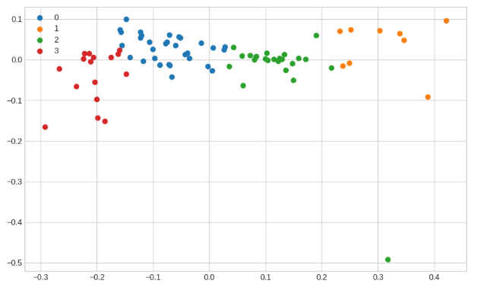
Department Segments Plot

Objective-
Develop personalized marketing strategies based on the store and department segments.
Propose inventory management strategies tailored to store and department needs.

Significance of Personalization Strategies
The significance of personalization strategies lies in their ability to tailor products, services, and marketing efforts to meet the specific needs and preferences of individual customers. By personalizing interactions and experiences, businesses can enhance customer satisfaction, loyalty, and engagement.

Significance of Inventory management Strategies
Inventory management strategies are significant for several reasons:
Cost Optimization: Effective inventory management helps minimize storage costs by preventing overstocking or stockouts, thus optimizing inventory levels and reducing holding costs.
Improved Cash Flow: By maintaining optimal inventory levels, businesses can free up capital that would otherwise be tied up in excess inventory, leading to improved cash flow and liquidity.

Personalization Strategies for Store Segments
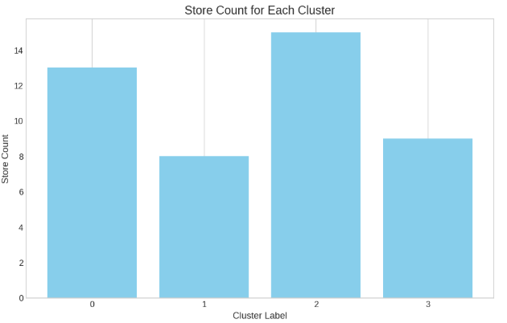
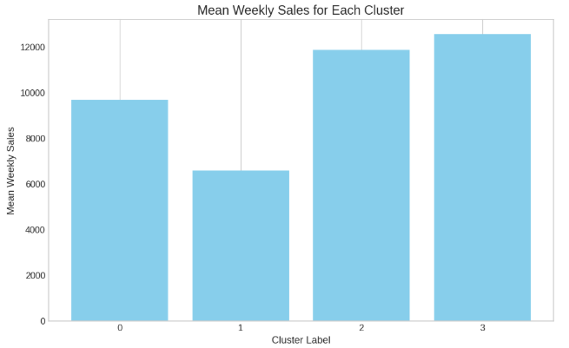
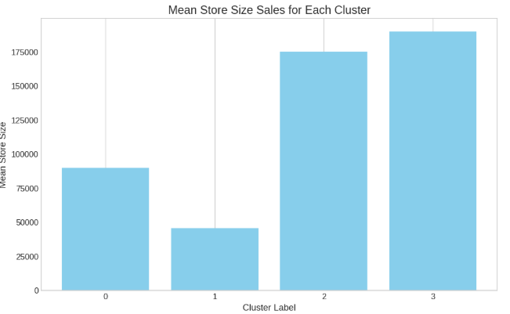
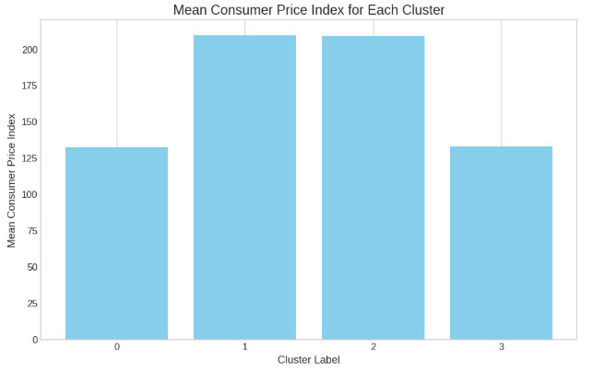
Personalization Strategies for Store Segments

Cluster 0: Compact Elegance Stores
This cluster encompasses stores known for their smaller physical dimensions and stands out for having a higher mean consumer price index compared to other clusters. The average weekly sales in Cluster 0 stores total 9672, which is relatively lower, with a total of 13 stores belonging to this group.

Cluster 1: Budget-Friendly Stores
This cluster represents stores characterized by their lowest average weekly sales, totalling 6579. These stores are notable for their small physical footprint and have the lowest mean consumer price index among the clusters. With a total of 8 stores in this group, it can be defined as comprising stores catering to consumers seeking lower-priced products in compact retail spaces.

Cluster 2: Value-Oriented Stores
This cluster represents stores with an average weekly sales totaling 11848, with 15 stores in total. It ranks as the second-largest cluster in terms of store sizes and is notable for having the lowest mean consumer price index. Described as comprising stores with medium physical space, it caters to consumers seeking lower-priced products while offering value-oriented shopping experiences.

Cluster 3: Premium Space Retailers & Sizeable Luxury Stores
This cluster consists of stores known for their larger physical footprint and is distinguished by having the highest mean consumer price index among the clusters. The average weekly sales in Cluster 3 stores total 12559, with a total of 9 stores belonging to this group. This cluster can be defined as comprising stores with significant physical space and catering to consumers with higher-priced products.

Personalization Strategies for Department Segments
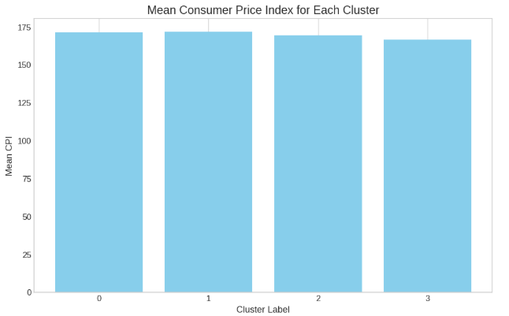
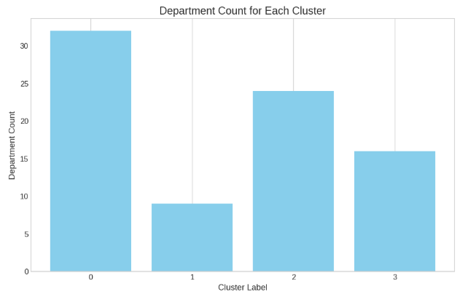
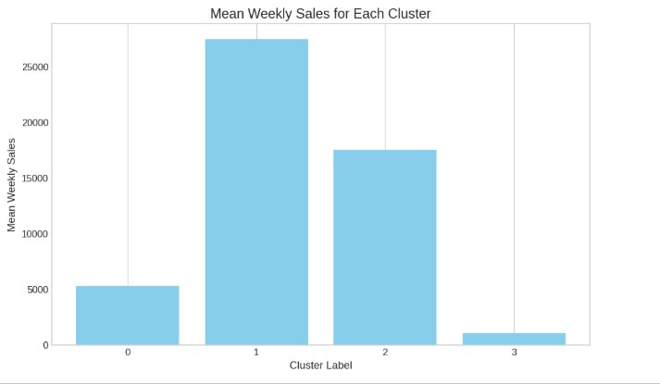
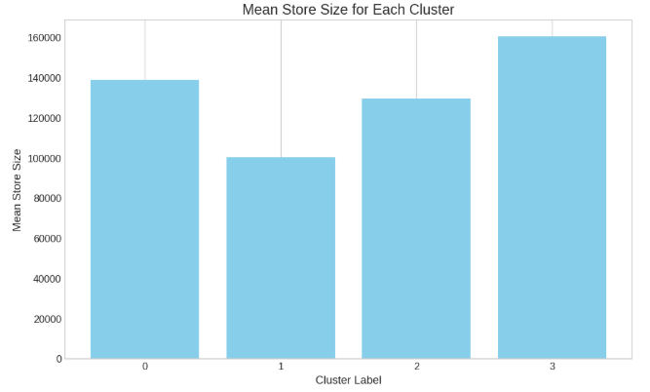

Personalization Strategies for Department Segments

Cluster 0: Premium Selection Departments
This department cluster consists of stores with an average weekly sales totalling 5307, spread across 32 departments. It is the third-largest cluster in terms of store sizes and is distinguished by having the highest mean consumer price index. Characterized by medium-sized physical spaces, this cluster caters to consumers who prefer higher-priced products.

Cluster 1: Grand Outlets Department
This department cluster comprises departments recognized for their larger physical size and stands out for having a lower mean consumer price index compared to other clusters. The average weekly sales in Cluster 9 departments total 27,479, which is notably high and represents an outlier, with only 1 department belonging to this group.

Cluster 2: Elite Departments
This department cluster consists of departments known for their higher average weekly sales, totalling 17,504. These departments are distinguished by their compact physical footprint and possess the highest mean consumer price index among the clusters. With a total of 24 stores in this group, it can be described as encompassing departments.

Cluster 3: Sizeable Luxury Departments
This department cluster comprises stores characterized by their expansive physical space and stands out for having the highest mean consumer price index among the clusters. The average weekly sales in Department Cluster 3 total 1085, with a total of 16 departments belonging to this group. This cluster can be described as encompassing stores with a substantial number of departments, exhibiting dismal mean weekly sales, and catering to consumers with premium-priced products.

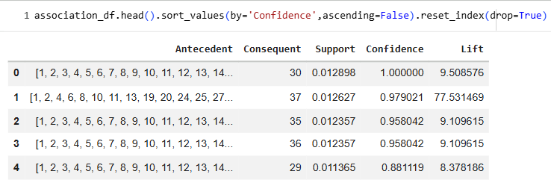
Market Basket Analysis

The output of the analysis consists of association rules that reveal relationships between departments. Each rule specifies a set of items (antecedent) that are associated with another set of items (consequent). For example, a rule might indicate that when department 29 is present, items in stores 1, 2, 3, ..., 45 tend to be purchased together.

Objective-
In market basket analysis we have tried to find out the association within different departments with the different stores in the given sales data.
Develop cross-selling strategies based on these inferences.
Significance of Market Basket Analysis
Market basket analysis is a strategic data mining technique used by retailers to enhance sales by gaining a deeper understanding of customer purchasing patterns. This method involves examining substantial datasets, such as historical purchase records, to unveil inherent product groupings and identify items that customers tend to buy together.
By recognizing these patterns of co-occurrence, retailers can make informed decisions to optimize inventory management, devise effective marketing strategies, employ cross-selling tactics.
Algorithms Used in Market Basket Analysis in Retail Data
The Apriori Algorithm widely uses and is well-known for Association Rule mining, making it a popular choice in market basket analysis.
Market Basket Analysis

Implementation:
The Apriori algorithm is applied to the sales data with specific parameters such as minimum support, confidence, lift, and length. This algorithm efficiently discovers frequent itemset and generates association rules based on these itemset.

Association Results:
The association results are printed out, showing each association rule along with its support, confidence, and lift. For example, a rule might indicate that when department 29 is present, there is a high confidence (e.g., 95%) that stores 1, 2, 3, ..., 45 will also be present in the same transaction, with a lift value indicating the strength of the association.
Overall, our approach encompasses standard practices in market basket analysis and leverages the Apriori algorithm to uncover meaningful associations within the provided sales data, which can lead to actionable insights for optimizing product placement, cross-selling strategies, and marketing efforts across different departments and stores.

Market Basket Analysis

Develop cross-selling strategies based on these inferences
Optimize Store Layout:
Utilize the associations between departments and stores to optimize the layout of each store. Place related departments in close proximity to each other within the store to encourage cross-store purchases. For example, if departments 29 and 30 are frequently purchased together across various stores, consider placing them adjacent to each other to facilitate cross-department sales.
Create Bundled Offers:
Identify departments that exhibit strong associations across multiple stores, such as departments 35 and 36. Create bundled offers or package deals that include products from both departments to incentivize customers to make cross-department purchases.
Targeted Promotions:
Develop targeted promotions and marketing campaigns based on the associations between departments and stores. For instance, if department 37 frequently co-occurs with departments 1, 2, 4, and 40 across different stores, create promotions that span these departments to capitalize on customer purchase patterns.
Dynamic Pricing Strategies:
Adjust pricing strategies based on the associations between departments and stores. Offer discounts or special pricing for products that are frequently purchased together across different stores to stimulate sales and increase customer satisfaction.

Demand Forecasting
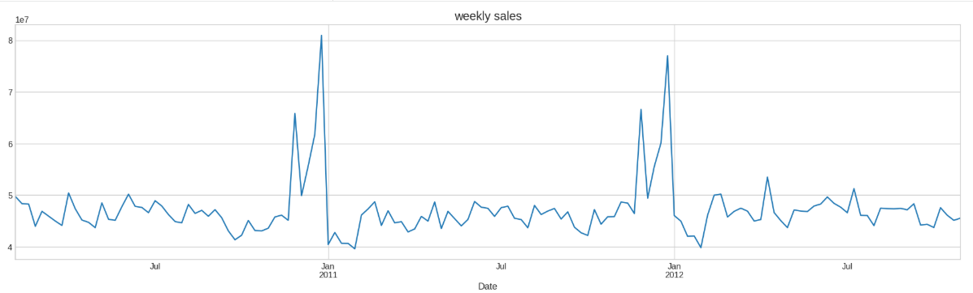
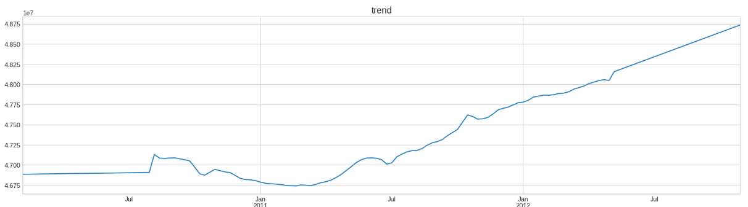
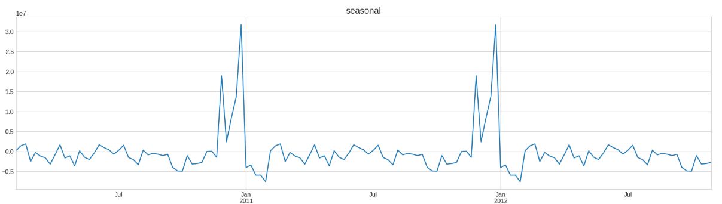
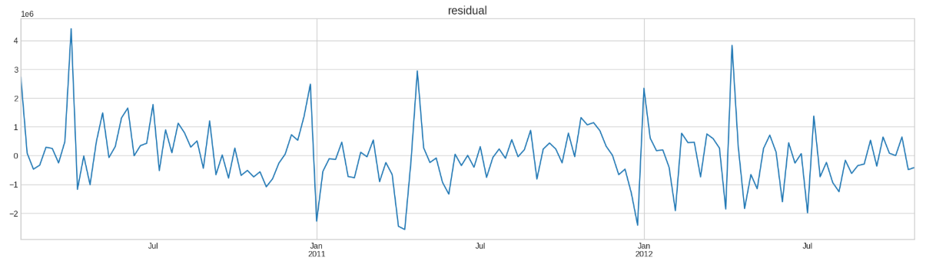
As it can be observed, the series is strongly influenced by the seasonal component

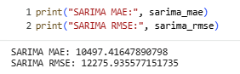
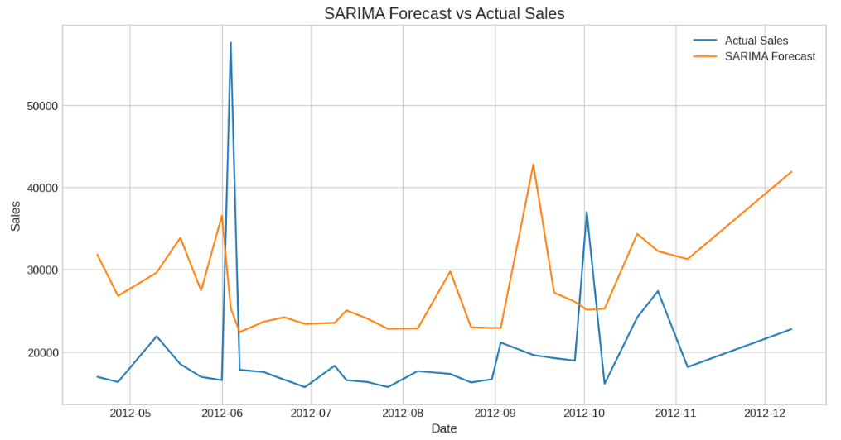

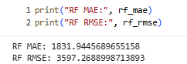
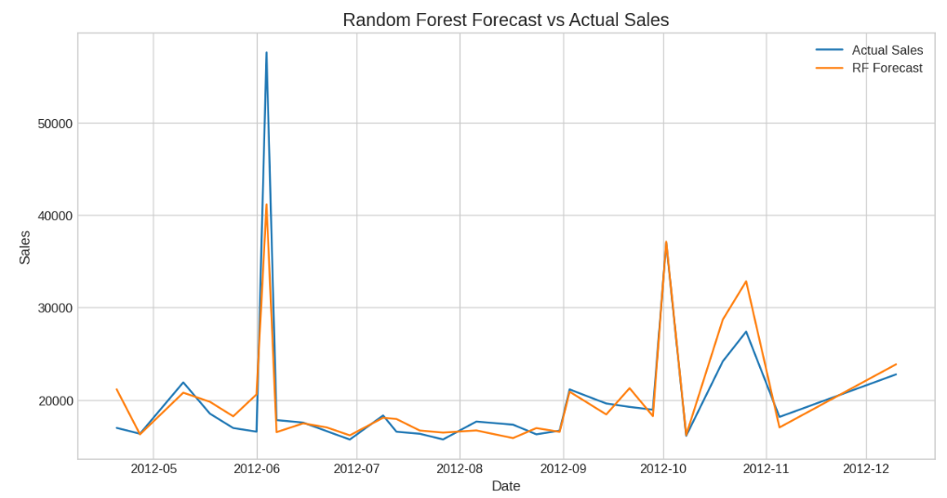

Objective-
Build models to forecast weekly sales for each store and department.
Incorporate factors like CPI, unemployment rate, fuel prices, and store/dept attributes.
Explore short-term and long-term forecasting models.

Significance of Demand Forecasting
Demand forecasting is a process used by businesses to predict future customer demand for their products or services.
It involves analyzing historical sales data, market trends, and other relevant factors to estimate the quantity of goods or services that customers are likely to purchase over a specific period of time.

Models Used for Demand Forecasting in Retail Data
Short-term forecasting model (SARIMA)-
Predicting future events or values over a relatively brief period, often within weeks or months, for immediate operational decisions.
Long-term forecasting model (Random Forest)-
Predicting future trends and values over an extended period, typically spanning months to years, for strategic planning and decision-making.

Demand Forecasting

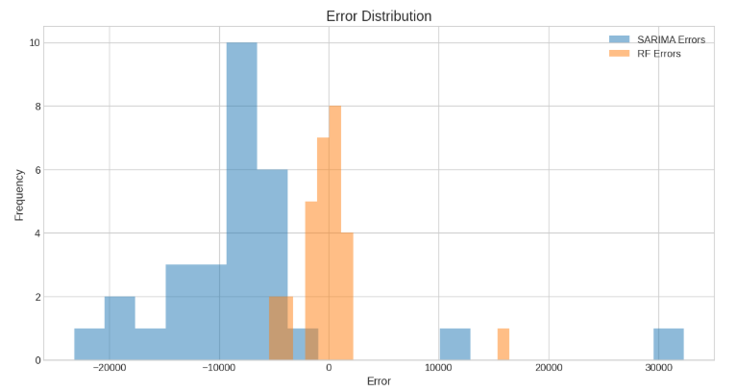
Error Distribution in Short term vs long term forecasting model
The error distribution plot demonstrates that the distribution in long-term forecasting random forest model adheres to a Gaussian curve.

Forecasting for 2013
Forecasting using the Holt-Winters Model
To perform forecasting using the Holt-Winters Model, also known as Triple Exponential Smoothing.
We can leverage the Holt-Winters Model to perform forecasting and predict future weekly sales for each store and department, taking into account the level, trend, and seasonality components of the data.

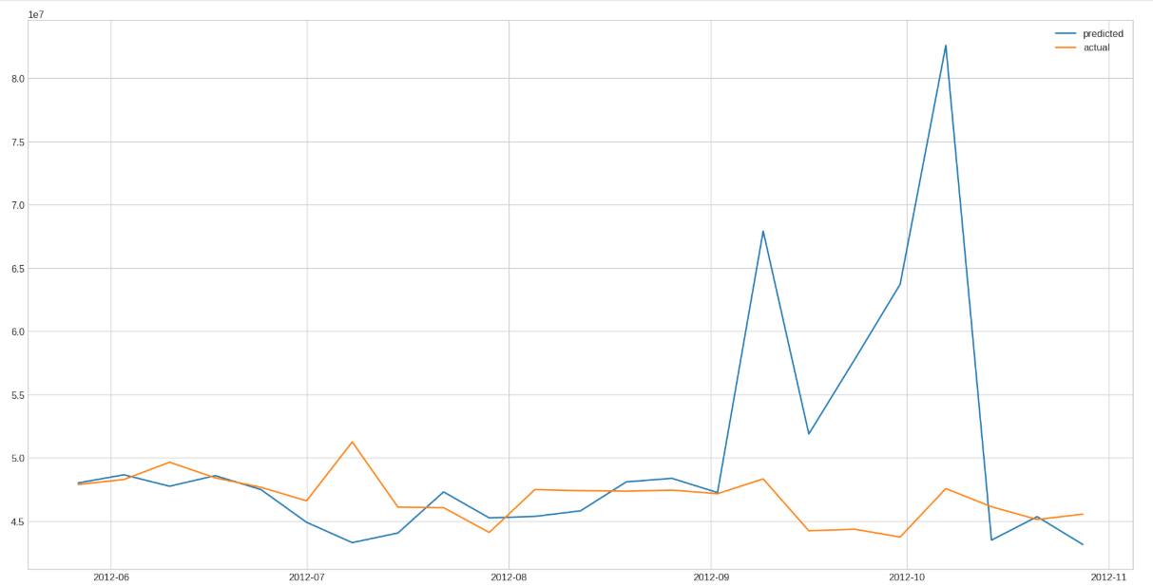
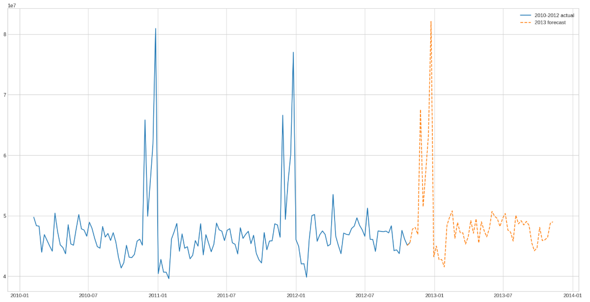
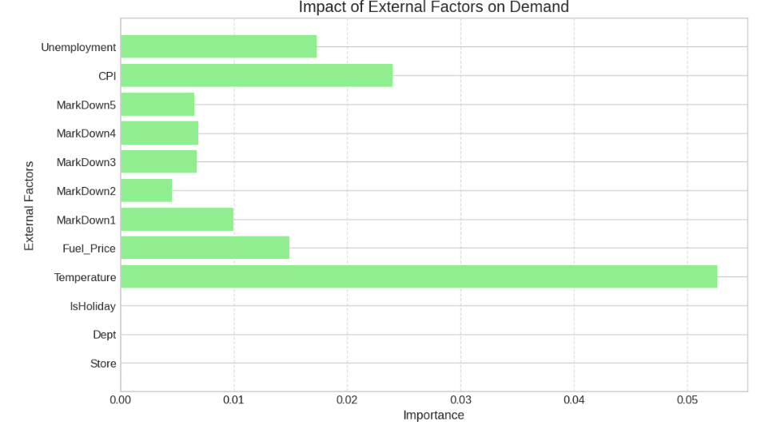
Impact of External Factors

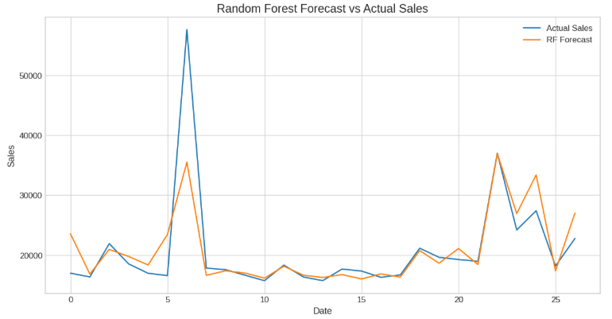
As it can be observed, the top 3 external factors which impact the demand forecasting in long term forecasting were temperature, consumer price index and fuel price.

Objective-
Examine how external factors (economic indicators, regional climate) influence sales.
Incorporate these insights into the demand forecasting models.

Impact of external factors in Demand Forecasting
Temperature
It plays a significant role in shaping consumer demand, especially for seasonal products and services.
During colder months, there is typically an increased demand for products such as winter clothing, heating appliances, and comfort foods. Conversely, warmer temperatures can lead to higher demand for items like outdoor recreational equipment, summer clothing, and cold beverages.
Consumer Price Index (CPI) and Fuel Price Index
- The CPI is a measure of the average change over time in the prices paid by urban consumers for a market basket of consumer goods and services.
- Changes in the CPI reflect inflationary or deflationary pressures in the economy, which directly impact consumers' purchasing power.
- Fluctuations in fuel prices directly affect operational costs for businesses involved in transportation and logistics, leading to changes in product pricing and availability.

Real-World Application and Strategy Formulation

Real-World Application and Strategy Formulation in Inventory Management

Seasonal Forecasting
Leverage temperature and weather trend data to predict seasonal variations in demand. Plan inventory levels, storage capacity, and resource allocation in advance to ensure adequate availability of seasonal products while minimizing excess stock.
Dynamic Pricing
Integrate Consumer Price Index (CPI) insights into pricing strategies to align with shifts in consumer purchasing power. Implement targeted promotions or discounts during low-inflation periods to encourage spending and maintain competitive positioning.
Supply Chain Optimization
Track fuel price movements to anticipate their impact on transportation and logistics costs. Optimize delivery routes, scheduling, and distribution networks to enhance efficiency and reduce the financial effects of fluctuating fuel prices.

Marketing Strategies
Targeted Campaigns
Design marketing initiatives based on regional climate and seasonal conditions to promote products that align with local needs. For instance, focus on winter apparel in colder regions and summer essentials in warmer markets to enhance relevance and engagement.
Price Sensitivity Analysis
Utilize CPI data to assess consumer reactions to price variations. Refine pricing strategies to strike a balance between profitability and market competitiveness while maintaining customer loyalty.
Promotional Timing
Align promotional activities with trends in fuel prices to support consumer spending behaviour. Introduce special offers or discounts during periods of lower fuel costs to encourage discretionary purchases and drive sales momentum.

Store Optimization
Product Placement
Design store layouts in alignment with seasonal demand trends derived from temperature and weather data. Position high-demand and seasonally relevant products in prominent locations to enhance visibility and encourage impulse purchases.
Inventory Turnover
Leverage CPI insights to maintain optimal inventory levels and reduce carrying costs. Adjust stock volumes in response to evolving consumer spending behaviour to improve turnover rates and prevent overstocking or stockouts.
Customer Experience
Utilize fuel price trends to introduce convenience-driven services such as online ordering, flexible delivery schedules, or curb side pickup. These initiatives help offset the impact of rising transportation costs while enhancing overall customer satisfaction.

Challenges in Implementing These Strategies

Data Integration
Achieving seamless integration of multiple data sources—such as temperature trends, CPI, and fuel prices—into existing business systems can be complex. Accurate forecasting and informed decision-making depend on the ability to consolidate and analyze this diverse data effectively.
Resource Allocation
Implementing dynamic pricing models and targeted marketing initiatives requires appropriate allocation of financial, technological, and human resources. Organizations must ensure that teams and tools are equipped to act on real-time data insights.
Operational Flexibility
Supply chain and inventory management processes must be agile enough to respond to external uncertainties, including sudden fuel price fluctuations or unexpected changes in consumer demand patterns.
Competitive Pressures
Adjusting pricing and promotional strategies while maintaining profitability can be challenging in highly competitive markets. Businesses must balance responsiveness to external factors with the need to protect market share and brand positioning.
Addressing these challenges requires strong technological infrastructure, strategic foresight, and organizational agility to effectively translate external insights into actionable business decisions.

Conclusion

This project aims to enhance store performance by improving demand forecasting, optimizing inventory management, and strengthening customer experience through segmentation and personalized marketing strategies.
By incorporating external factors such as regional climate conditions, the Consumer Price Index, and fuel price trends into our analysis, we have gained deeper insights into the key drivers influencing consumer behaviour and purchasing patterns.
Through an integrated approach to inventory planning, marketing initiatives, and store optimization, we seek to translate these insights into sustainable growth and a stronger competitive position. Tailoring strategies to the unique requirements of different stores and department segments enables us to deliver more relevant, engaging, and customer-centric experiences.
Leveraging data-driven tools such as dynamic pricing models and real-time inventory management, we can respond quickly to evolving market conditions and consumer preferences, ensuring optimal product availability while maintaining pricing competitiveness.

